YOUTUBE TOP 100

1. What are the categories in top 100?

SELECT Categories ,COUNT(Title) AS Total_Column FROM [youtube-top-100-songs-2025] Group by Categories ;  
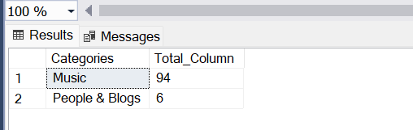

TH 22. What are the Top 5 channels with followers more than 1 million?

SELECT TOP 5 Channel, [Channel Follower Count] AS FamousArtist FROM [youtube-top-100-songs-2025] WHERE [Channel Follower Count]>1000000;

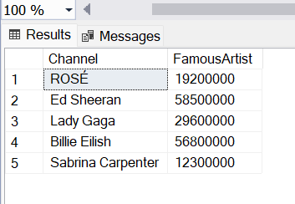

3.Which channels that have views more than 50 million?

SELECT Title, Channel FROM [youtube-top-100-songs-2025] where [View Count]>50000000;

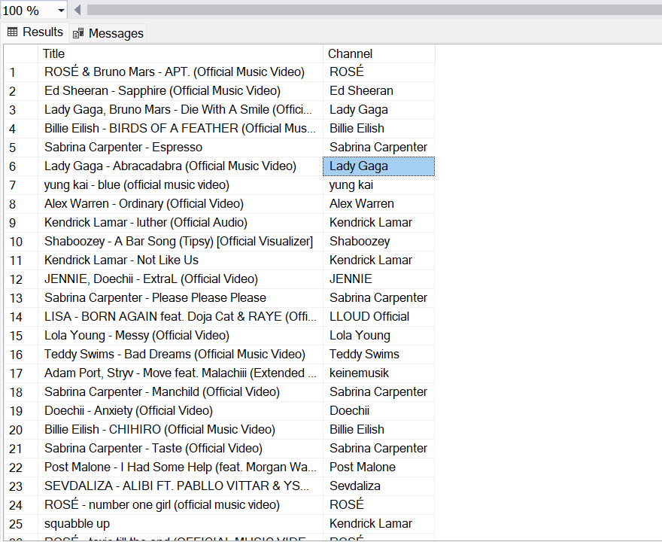

4.List the songs where the duration is greater than 180 seconds

SELECT Title ,Channel FROM [youtube-top-100-songs-2025] where Duration<180;

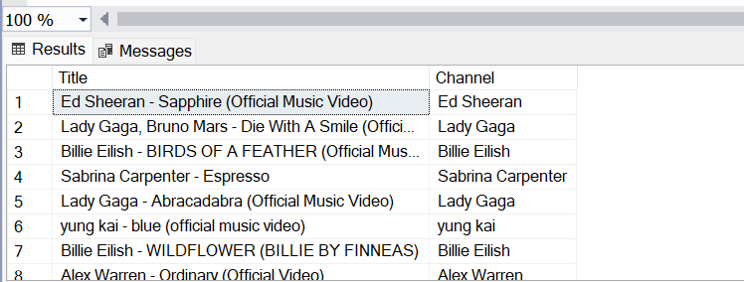

5. Which are the top 5 channels that have more than 2 songs in the YouTube Top 100 ?

SELECT TOP 5 Channel, COUNT(Channel) AS ChannelCount FROM [youtube-top-100-songs-2025] GROUP BY Channel HAVING COUNT(Channel) >= 2ORDER BY ChannelCount DESC;  
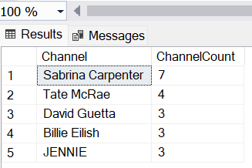

6.How many songs have null tags ?

SELECT Count(Title) AS NULLTags FROM [youtube-top-100-songs-2025] where Tags is Null;  
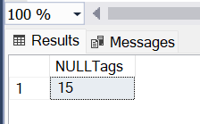

7. List of the Songs and Channels where category is People and Blog and duration is greater than 180 seconds

SELECT Title , Channel from [youtube-top-100-songs-2025] where Categories='People & Blogs' AND Duration > 180;

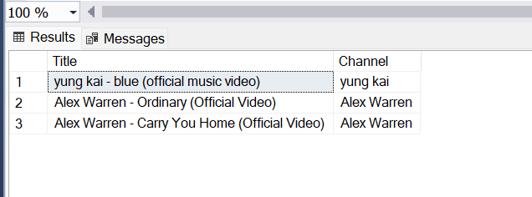

8.List of songs where FullTitle contains Taylor

SELECT Title , Description From [youtube-top-100-songs-2025] where FullTitle LIKE '%Taylor%';  
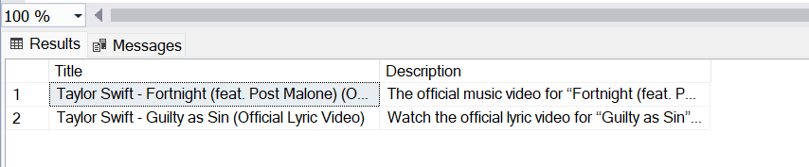

9. Total No of Selena songs

SELECT COUNT(Title)TotalSelenaSongs FROM [youtube-top-100-songs-2025] where Channel LIKE 'Selena%';  
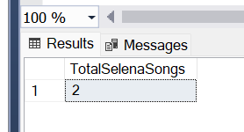

10. List of titles of songs where the View Count is more than the Maximum View Count of Sabrina

SELECT Title , Channel FROM [youtube-top-100-songs-2025] where [View Count]>(Select MAX([View Count]) FROM [youtube-top-100-songs-2025] WHERE Channel LIKE 'Sabrina%');  
